1st Edition 2009
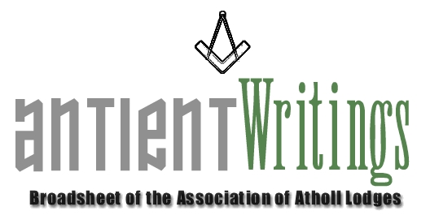

New Blood - URGENT

What about you !!! - Especially if you are interested in joining the Executive Committee, which meets 3 times a year. The Committee is now urgently succession planning for the roles of:

1. Secretary - 2010 onwards 2. Events Organiser - For Induction in 2009

It is hoped that many Atholl lodges will respond to this appeal and put forward willing brethren to maintain the work of the Association through active membership of its Executive Committee.

Annual General Meeting

The 2009 Annual General Meeting will be held at Freemasons Hall, Gt Queen Street, on Wed 1st July at 6pm. Notices of Motion must be received by the Secretary by 3rd June. All are welcome to attend, volunteers especially.

NEW MEMBERSHIP SECRETARY - Have you renewed your Membership Subscription ?

The 2009 renewals are due and the 15 who acted on the request in the last Antient Writings are thanked for their prompt response. However, many have not yet renewed so a further form is enclosed with this mailing. Please support YOUR Association ! Terry Mahoney is our new membership secretary and in March he will be writing to lodge secretaries to make sure they have not forgotten to renew or join. The fees are £10 for all categories and £5 for individuals. Terry can be contacted at 6 St. Matthews Drive, St. Leonard’s on Sea, East Sussex, TN38 0TR. Tel. No. 01424 713004. His wife Eileen will likely take his calls. Email: terrymahoney@btinternet.com

Web Site - www.antients.com and webmaster@antients.com

Versions of ‘your’ lodge history can be easily added to the web site and the Webmaster, Neil, will be pleased to hear from you. He will also post any other relevant ‘Atholl’ information or advertisements.

QuestionTime !

The Association is planning a ‘unique’ event in the Autumn to be held in London, possibly on 14th October. This will be hosted by Kent Lodge No.15 and take the form of a QuestionTime. The panel will be made up of eminent freemasons and Rulers and it will be your opportunity to ‘ask’ that question that has always vexed you. The outline plan is for a two hour event at Freemasons Hall with some pre-submitted questions together with some taken from the floor via a question master. They will then be offered to the panel for opinion and views according to subject matter.
Afterwards those who wish to dine will be most welcome at the Lodge’s Festive Board at the Connaught Rooms. The cost will be in the region of £5 for the event or £40 with dining [inc wine]. The Secretary will require an early indication of how many wish to attend and for those with a burning topic an outline of their question. Some questions may be conjoined. Email to secretary@antients.com. Look out for posters and check the website for full details when finalised.

New York Visit – Proposed Late 2009

This trip is proving somewhat troublesome and awaits confirmation and dates. But Lew is on the case. The plan is to fly out on a Monday. Visit Grand lodge of New York and take in a meeting on Tuesday. Take an Amtrak train to Philadelphia-sight seeing-meeting and return on Wednesday. Thursday New York site seeing/shopping. Return on Friday. Contact Lew Hughes on derek.muffin@virgin.net and keep an eye on the web site for updates.

New Hope – Rescue a Lodge

A group of ‘Atholl’ enthusiasts are willing to ‘rescue’ an antient lodge rather than let it surrender its Warrant. The plan would be to enrich its membership and move it to Sindlesham, Berkshire where it would have a secure home and future. Any Atholl lodge in dire straits please make contact before it is too late.

Merchandise

Ties / Bow Ties / Lapel Pins are available from the Secretary. They are £12.50 and £2.50 respectively. There is also a ‘longer’ version of the tie available. The book on the life of Laurence Dermott is also available at £6 inc UK postage.
You are permitted to wear Association ties at Atholl meetings.

Would Secretaries and Representatives photocopy and distribute as widely as possible

Paul Gardner - 39 Wentworth Drive, Bedford, BEDS, MK41 8QA - 01234 261584 secretary@antients.com

